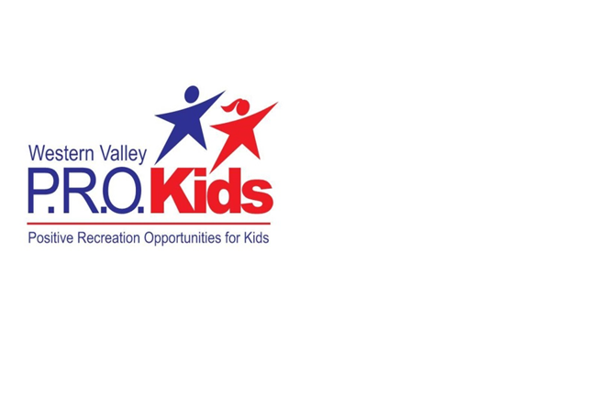
Contact: Connie Trecartin, Coordinator - 506-375-0814
Deadline: First come first serve
Age: 18 and Under
Amount: $300 per calendar year
Funding Caps: Ages: 0 – 3 $50 per activity (that is $100 & Under)
Ages: 4 – 6 $100 per activity (that is $300 & Under)
Ages: 7 – 18 $300 per activity
Guidelines: Funding for a recreation, sport or cultural program and who are not currently participating in other paid recreation programs. It is not intended to supplement participation in more than one activity at a time. Application(s) cannot be receiving funding from other Organizations or Foundations; etc.
Application:
Step 1: Apply ”online- only” to PRO Kids – www.wvra.ca
Step 2: On the Top Bar go to the P.R.O. Kids Tab
Step 3: Click on the tab and click “About”. This will bring up the guidelines for the application process. Follow the instructions.
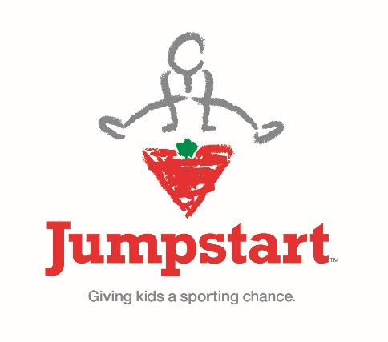
Step 4: Once guidelines are ready you can click on the bottom of this page “Click Here to Apply” or go back up to the P.R.O. Kids tab and click “Application”
*************************************************************************************

Deadline: Mid January to Mid-November
Amount: Up to $300 per calendar year
Age: 4 to 18 year olds
Guidelines: Funding available for any sustained program that lasts a season.
Funding must be for on-going programs or activities.
Application: http://jumpstart.canadiantire.ca/en

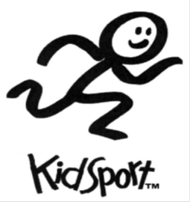
*************************************************************************************

Contact: Hillary Pineau: programs@sportnb.com: 506-451-1320
Deadlines: January 31, May 1, September 1
Amount: $200 per calendar year
Age: 18 and Under
Guidelines: Sport activity must be recognized by Sport NB. Funding is for registration and equipment fees. School Sports and travel are not eligible expenses.
Application: http://kidsportcanada.ca/new-brunswick or call 1-506-451-1320 or 1-888-KIDSPORT.

